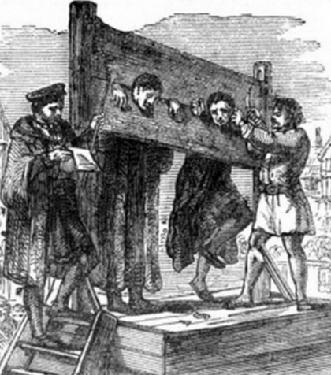 |  | Year 6 Autumn 1  Topic Overview -  Our theme this term is ‘Crime and Punishment’. We will explore the crimes and punishments through the different eras before looking at our justice system and how it works today. We will be conducting a case study on a significant person relating to our unit and investigate the concept of rehabilitation and punishment within the prison system.
Super Start: Children will become judges, jurors and executioners. They will hold trials at court and decided on the suitable punishment.
Marvelous Middle: Visit to the Tower of London
Fab Finish: Showcase of Art. (Graffiti and Street art)
Our Learning Overview
Key Texts

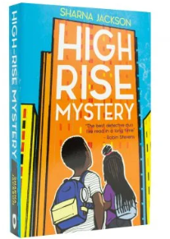

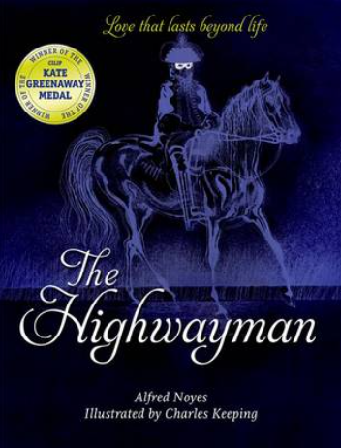

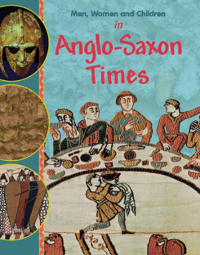

 |  |  |  |  | English |  | We will start the term by looking at ‘The Highwayman’. We will use the first text to learn about the world around us and the impact we have on it, before using ‘The Highwayman’ to develop our own police reports and stories. We are going on to read ‘Men, Women and Children in Anglo-Saxon times’ in our reading sessions, focusing on retrieval and text scanning for information.
 |  |  |  |  | Maths |  | . Our focus will be on Place Value, multiplying and dividing larger numbers and fractions along with percentages and decimals.
 | Does the Time Fit  the Crime? |  |  |  | Science |  | In Science, we will be learning about Animals including Humans. The children will look at how to stay healthy. They will learn about their heart rates as well as the different food groups.  They will learn who James Lind is and why he played a part in understanding how to prevent diseases.
 |  |  |  |  | History |  | In History we will learn about crimes and punishments. We will start by looking at Ancient Rome and then move on to the Anglo-Saxon era, the Tudor era and the Victorian era. We will then look at crime and punishment during WWII, right up until today and how our laws work now.
 |  |  |  |  | Art/DT |  | In Art, we will use a combination of our art knowledge and media to design Banksy art pieces. We will focus on his style of graffiti and street art.
 |  |  |  |  | PHSE/RE |  | In PSHE, we will be exploring the topic ‘Being Me in my World’. We will focus on how to work in a team and form relationships. For RE, we will look at Islam and discuss the question, ‘What is the best way for a Muslim to show commitment to God?’
 |  |  |  |  | Music |  | Along with their weekly music lesson, year 6 will also have violin Lessons, that also include, singing, call and response musical learning and extending the Kodaly teaching techniques that have been laid down in the past.

