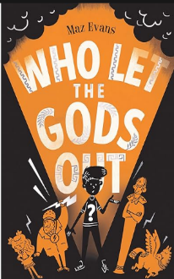 |  |   Year 5, Autumn 1  Topic Overview – Ancient Influencers  This term, the children will be diving into the world of Ancient Greece. They’ll journey through history, discovering influential figures like Alexander the Great and learning about his incredible power and legacy. The children will also delve into ancient Greek mythology, exploring the many gods and how they were worshipped by people on Earth.
Super Start: Children will be creating an Ancient Greek inspired shield!
Epic End: Learning Showcase
Our Learning Overview
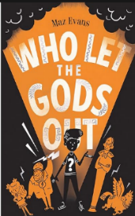
Key Texts

Trips:

British Museum

 |  |  |  |  | English | . | This half-term in writing, children will begin by exploring emotions and feelings inspired by the film *Inside Out 2*. They will then expand their vocabulary through the study of mythical poems. Following this, they’ll create their own Greek myth and finish by writing instructions on how to defeat a mythical beast!
 |  |  |  |  | Maths |  | We will be starting the Autumn term with Place value! It is essential that children build on their foundational knowledge to secure their mathematical knowledge and understanding. As a cohort, the children will enhance their arithmetic skills and consolidate this through reasoning.
 | 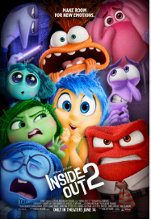 |  |  |  | Science |  | As scientists, the children will be learning about forces. Children will be learning about understanding gravity as a force, exploring air resistance and water resistance and recognising how levers, pulleys and gears help us to use less force.
 |  |  |  |  | History |  | We will be exploring Ancient Greece. Looking at where the empire was located and how it began. We will delve into key aspects of Greek culture such as myths and legends, the gods and goddesses and the original Olympics. We will look at change and continuity and explore how the Greek Empire has impacted life today.
 |  |  |  |  | Art/DT |  | As artists, the children will be exploring Greek pottery. We will be observing different styles of artwork and using subject-related vocabulary to describe different styles of the pots themselves. We will be recreating our own freestanding Greek pots using paper mache.
 |  |  |  |  | PSHE/RE |  | RE - Children will understand how Hindus show their commitment to God.  PSHE – The name of our topic is ‘Being in My World’. This topic will provide opportunities for children to  upon solving problems with friends, showing respect and understanding what makes a good relationship.
 |  |  |  |  | Music |  | This year we will be learning to play the ukelele! We will also be developing skills in learning notation and ensemble playing techniques with instruments they are familiar with.

