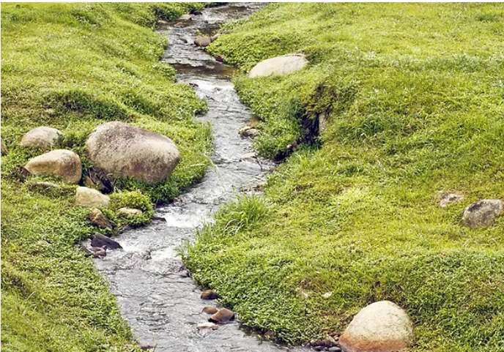 |  |   Year 4 Autumn 1  Topic Overview – Back to the Source  For our topic, we will be learning about the stages of a river and the water cycle. We will also be learning about the Cutty Sark and the tea trade and how the tea was transported along the River Thames.
 |  | Super Start: We will be exploring the water cycle by creating our own moving version and then designing our own rivers using different features.
Our Learning Overview
Key Text

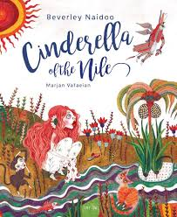
 |  |  |  |  | English |  | In English, we will be building up our SPAG skills including fronted adverbials and apostrophes. We will demonstrate this through our narrative, persuasive and recount writing.
 |  |  |  |  | Maths |  | We will be learning about place value and partitioning numbers into ones, tens, hundreds and thousands. We will recognize the place value of a digit in a number and use this to order and compare numbers and say which number is more or less.
 | Back to the Source |  |  |  | Science |  | For our Science learning, we will be learning about “States of matter”. In this area we will be learning about solids, liquids and gases: exploring how matter can change between state.
 |  |  |  |  | Geography/History |  | In Geography, we will be learning about rivers and the different stages of a river. This will include learning about the water cycle.  In History we will be learning about the Cutty Sark and its links to the tea trade.
 |  |  |  |  | Art |  | In Art, we will be learning about the work of Stephen Whiltshire, this will involve us developing our drawing and sketching skills, developing our ability to draw in 3D.
 |  |  |  |  | PSHE/RE |  | Our PSHE topic will be “Being Me in My World.” This will involve learning about feelings, relationships and how to work collaboratively. In RE we will be focusing on Buddhism, answering the question ‘Is it possible for everyone to be happy?’
 |  |  |  |  | Music |  | In Music, we will be continuing some of our work using recorders and glockenspiels, also practicing our singing and percussion. We will also be introducing the children to a new instrument: the ukulele.

