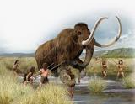 |  |   Year 3 Autumn 1  Topic Overview – Rock of Ages  The children will be using their understanding to: place the prehistoric periods accurately on a timeline, investigate and compare the Paleolithic, Mesolithic and Neolithic periods of the Stone Age and explore the Bronze and Iron Ages and their significance.
Super Start: The children will be creating their own stone age influenced artwork, tools, and artefacts.
Epic End: The children will create their 3D stone age influenced creations and will present all aspects of their learning during their learning showcase.
Our Learning Overview
Key Texts
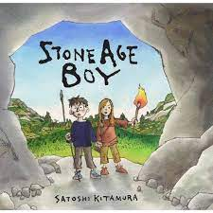
Stone Age Boy

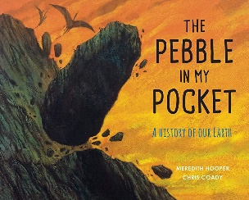
Pebble in my Pocket

 |  |  |  |  | English |  | In English, focusing on the text The Pebble in My Pocket, children will write their own narrative story, incorporating a setting description using their senses. They will also write a persuasive text linked to themes from the book.
 |  |  |  |  | Maths |  | Children will be learning about place value, looking at hundreds and thousands. They will be learning to represent and partition these numbers. They will then be moving on to addition and subtraction, in which they will adding and subtracting 10s and 100s, before completing inverse calculations to check their answers.
 | Rock of Ages |  |  |  | Science |  | For our Science learning, we will be naming types of rocks, giving physical features of different types of rocks, explaining how a fossil is formed, classifying rocks in different ways, devising tests to explore the properties of rocks and observing how rocks change over time.
 |  |  |  |  | History |  | In History, we will be exploring the stone age and using evidence to find answers to questions about the past, identify some of the different ways in which the past has been represented and show some of the similarities and differences between different periods.
 |  |  |  |  | Art |  | In Design and Technology, we will explore how levers and linkages work. Children will design and create moving mechanisms, learning how simple machines can make movement easier. They will test materials and think about how to improve their designs.
 |  |  |  |  | PSHE/RE |  | During PSHE, the children will recognise their worth and identify positive things  about themselves and achievements. In RE, the children will be learning about Sikhism and will explore and describe a range of beliefs, symbols and actions so that they can understand different ways of life and ways of expressing meaning.
 |  |  |  |  | Music |  | In Music, children will develop their skills through learning recorder and glockenspiel, with an introduction to ukulele and continued development. They will also take part in singing and percussion activities to build confidence and musical understanding.

