 |  |   Year 2 Autumn 1  This term we will be comparing the human and physical geography of Australia and England. We will build on our knowledge of seasons, continents and oceans from last year to investigate similarities and differences between them focusing on specific areas such as London and Sydney.
Super Start:
We will be looking at the weather in Australia and learning Australian phrases and decorating a boomerang.
Epic End: Art gallery showcasing all the art work produced throughout the term. Singing an Australian song using sign language.
Our Learning Overview
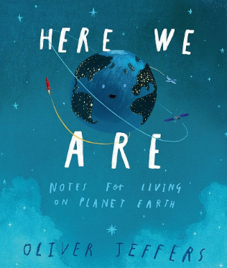
Key Texts

Here we are by Oliver Jeffers
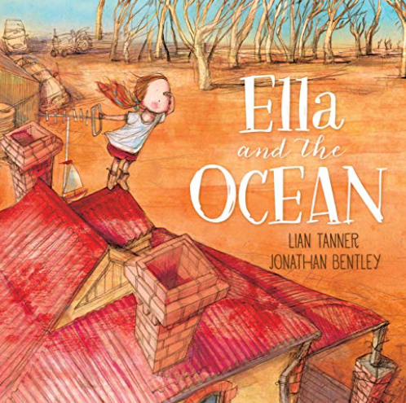

Ella and the Ocean by Liam Tanner and Johnathon Bentley,
 |  |  |  |  | English |  | In English, we will be writing a narrative using expanded noun phrases language focusing on media clips and our class novel. We will also be writing our recount based on a science experiment or our class workshop.
 |  |  |  |  | Maths |  | In Maths, we will be looking at place value. We will look at our number bonds, number recognition and partitioning numbers using different methods. We will be focusing on our 2-, 5- and 10-times tables.
 | Come from a land down under |  |  |  | Science |  | In Science, we will be looking at Animals Including Humans. We will explore adults and their offspring, looking at their life cycles of both animals and humans. We will learn the importance of keeping both animals and humans alive.
 |  |  |  |  | Geography |  | In Geography will be comparing where Australia and England are located. We will discuss similarities and differences such as their religious differences, weather conditions and famous landmarks.
 |  |  |  |  | Art |  | In Art we will be exploring Aboriginal Art. We will create an Australian painting using different techniques. We will draw Australian animals using primary and secondary colours.
 |  |  |  |  | PSHE/RE |  | In RE we will be learning about Christianity. We will look at Easter, Christmas, church, prayer and God. In PSHE we are looking at ‘Being me in my world’ exploring how we fit in the world.
 |  |  |  |  | Music |  | In Music we will taking part in a weekly music session with a specialist teacher. We will be learning songs and focus on rhythm and pitch.  .

