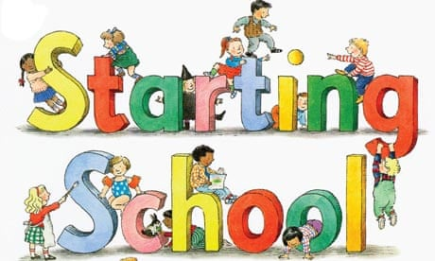 |     Reception Autumn 1  Topic Overview – Magnificent Me  This term in Reception, we will learn through carefully chosen key texts. We will learn through the stories, and follow White Rose Maths. We will start phonics and practise our writing daily.
Super Start: We will undertake many fun activities to launch our topic. Have a look on Class Dojo to see what your child has taken part in.
Epic End Parents and carers are invited in for Family Fun Morning – Tuesday 14th October 2025.
How you can help your child
- Send your child with their book bag every day and a water bottle. Make sure they bring their guided reading book every day in their book bag.
- Encourage your child to change themselves at home.
- Ensure they bring in their P.E kit to school on Mondays (Blue or white t-shirt, tracksuit top and bottoms and plimsolls or black trainers). Please make sure their name is everything that belongs to them. PE kits will go home on Fridays
- Encourage your child to read at home every day and recorded this in their contact book.
Our Learning Overview
Key Texts
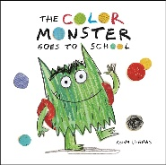
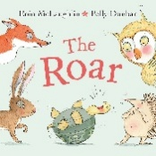
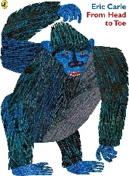
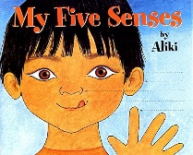
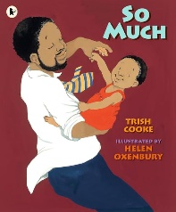
Topic Vocabulary
Head  Eyes  Ears  Nose  Mouth  Teeth  Tongue  Neck  Shoulders  Arms  Hands  Fingers  Chest  Back  Stomach  Legs  Feet  Toes  Hair  Eyes  Skin | Happy  Sad  Angry  Excited  Surprised  Bored  Scared  Proud  Shy  Brave  Confused  Worried  Love  Jealous  Me  I | Name  Age  Birthday  Family  Mum  Dad  Brother  Sister  Grandparents  Aunt  Uncle  Cousin  Friend  Pet  You | Wash  Brush  Shower  Bath  Dress  Undress  Sleep  Eat  Drink  Toilet  Change  Hands up!  Mine  Same  Big | Favourite  Like  Dislike  Best  Colour  Food  Drink  Animal  Game  Toy  Yours  Different  Small
Colour Monster Goes to School | The Roar | So Much | From Head to Toe | My Five Senses
Colour  Monster  Feelings  School  Happy  Sad  Angry  Scared  Excited  Friend  Class  Teacher  Emotion  Share  Learn | Roar  Sound  Lion  Fear  Brave  Dark  Forest  Adventure  Friend  Courage  Danger  Hide  Bravery  Wild  Explore | So  Much  Love  Family  Hug  Happy  Together  Cuddle  Play  Big  Small  Care  Important  More  Warm | Head  Toe  Body  Move  Stretch  Arms  Legs  Hands  Feet  Knees  Shoulders  Eyes  Mouth  Smile  Jump | Senses  Sight  Hearing  Touch  Taste  Smell  Eyes  Ears  Skin  Tongue  Nose  Soft  Loud  Sweet  Sour

