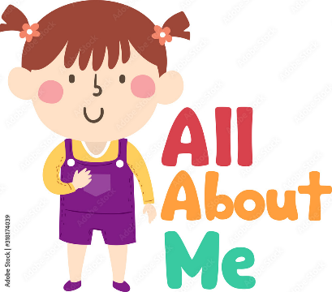 | EYFS – Nursery – Autumn 1  Topic Overview – All about me  This term children will be learning all about themselves and what makes them special. They will learn all about different types of families, what makes them unique and the similarities and differences between us.
Super Start: Self-portraits and family photos.
Marvellous Middle: Teddy’s Bear Picnic
Fab Finish: Family Fun Morning/Afternoon- Wednesday 15th October 2025
Our Learning Overview
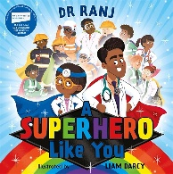
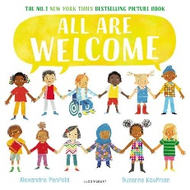
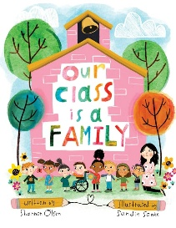
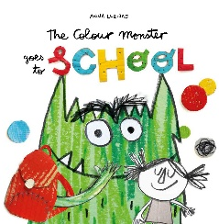
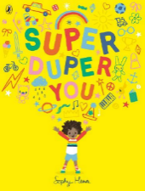
Key Texts
Topic Vocabulary
Play  Sing  Draw  Dance  Climb  Build  Friend  Share  Help  Hug  Talk  Listen  Respect | Family  Mum  Dad  Brother  Sister  Grandparents  Pet  Name  Age  Birthday | Happy  Sad  Angry  Excited  Surprised  Scared  Love  Confused  Worried | Head  Eyes  Ears  Nose  Mouth  Teeth  Hands  Fingers  Arms  Legs  Feet  Knees  Toes  Hair  Skin  Face
Colour Monster Goes to School | Super Duper You | A Super Power Like Mine | All Are Welcome | Our Class is a Family
Feelings  Friends  Happy  Sad  Angry  Calm  Fear | Strengths  Special  Difference  Power  Potential | Unique  Individuality  Determination  Brave  Confidence | Welcome  Everyone  School  Respect  Community | Family  Belonging  Relationships  Sharing  Trust

