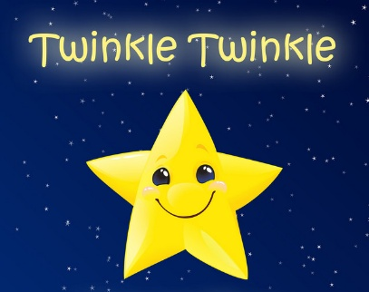 |     Nursery Autumn 2  Topic Overview – Twinkle Twinkle  This term in Nursery, we will continue to learn through carefully chosen nursery thymes. We will learn a different nursery rhyme every week and have planned provision for each rhyme.
Super Start: On Monday 3rd November 2025 the children can dress up as a Nursery Rhyme character, please support your child to learn the rhyme that their character is from. We will also make salt dough stars and star biscuits. Look on Class Dojo for photos.
Marvellous Middle: Perform/record a learnt nursery frame using actions alongside the words.
Epic End – Family Fun Morning/Afternoon
Our Learning Overview
Key Rhymes

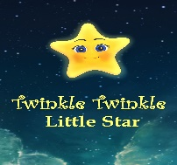
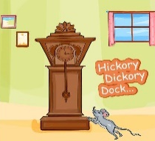

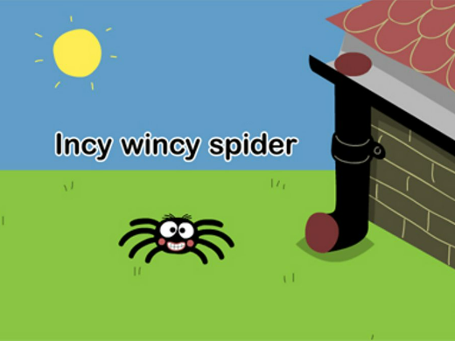

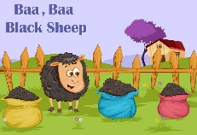

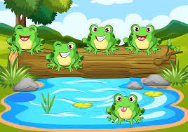
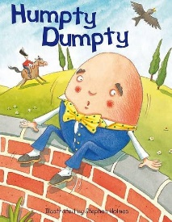

Topic Vocabulary
- Farm animals  - Pets:  - Wild animals:  - Bird  - Sing:  - Clap:  - Jump:  - Round and round | - Dance:  - Hop:  - Stamp:  - Moon:  - Stars:  - Clock:  - Shoes  - Hands  - Feet | - One:  - Five:  - Ten:  - More/Less:  - Morning:  - Night:  - Farm:  - Duck  - Quack | - Tick-tock:  - Baa:  - Buzz: or bee.  - Splash:  - Zoom:  - Spin:  - Wave  - Beat  - Tune | - Sleepy  - Excited  - Angry:  - Happy:  - Sad  - Rhymes  - Song
Incy wincy spider | Twinkle Twinkle Little Star | Baa Baa Black Sheep | Humpty Dumpty | Hickory Dickory Dock | 5 Little Speckled Frogs
Spider  Drain  Rain  Rhyme  Dried  Sun  Water spout  Washed  climbed | Star  World  Diamond  Sky  High  Twinkle | Baa –  Sheep  Wool  Sir  Full  Bags  Master  Dame  Lane | Horse  Wall  Fall  King  Men  Again  Put together | Clock  Mouse  Struck  Ran  Down  Tick-tock | Frogs  Log  Jump  Grub  Bugs  Pool  Cool

