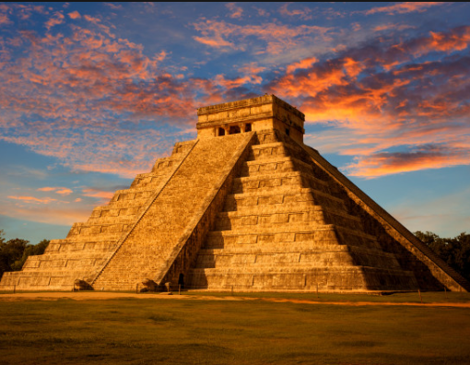 |  |  |  |   Year 4 Autumn 2  Topic Overview – Hola!  This term we will be learning all about the Ancient Mayan Civilization. We will be exploring the different periods of their civilization, alongside analysing the geographical landscape which they built upon. We will look at how they farmed and traded, alongside the social hierarchies of their states.
 |  |  |  | Super start: We will be immersed in Ancient Maya culture. We will create our own Mayan masks as well as design our own confidence building shields. Please can children bring spare cardboard for the activities. Children can come dressed as Ancient Mayans.
Our Learning Overview
Key Text

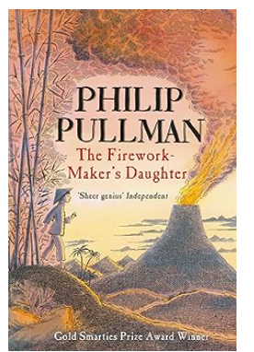
 |  |  |  |  | English |  | In English this term, we will be writing a range of genres basing our ideas off of our key text. We will be writing narratives, report writing and journalistic writing.
 |  |  |  |  | Maths |  | Students will be learning about multiplication and division, we will link this to the children learning their times tables, particularly their 3, 4, 6 and 8s. We will also be learning how to calculate area.
 | Hola! |  |  |  | Science |  | In Science, we will be exploring sound. We will look at how sound is transmitted, how we hear sounds and the structure of the ear. We will also be undertaking sound investigations.
 | Hola! |  |  |  | History |  | In History, we will be learning about an Ancient Civilisation- the Mayans. We will build on our historical knowledge learnt across Year 3 to compare their civilization to ones previously taught. We will also focus on their inventions and discoveries which we still use today.
 | Hola! |  |  |  | DT |  | In DT, we will be working with food, specifically rice. We will be testing and evaluating different rice dishes and using this knowledge to then design and make our own.
 |  |  |  |  | PSHE/RE |  | Our PSHE topic is ‘Celebrating Difference’ We will be exploring the differences between us that make us unique and how we can be tolerant and understanding of each other. In RE, we will be answering the question ‘What is the most significant part of the nativity story for Christians today?’
 |  |  |  |  | Music |  | In Music, we be learning how to play the glockenspiel to accompany songs and on its own. We will also be learning about musical rhythms.

