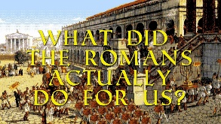 |  |   Year 3 Autumn 2  Topic Overview – What did the Romans do for us?  The children will use their understanding to place Roman invasions accurately on a map and a timeline. The children will explore the significance of the Roman Army and learn about important Roman Battles. They will also develop an understanding of what Romans did to support Britain.
Super Start: We will be making animal mosaics and Roman shields.
Fab Finish: Parent Gallery.
Our Learning Overview
Key Texts

Roman Diary: The Journal of Iliona

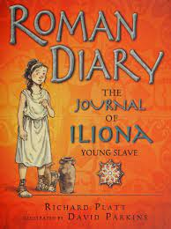

Escape from Pompeii

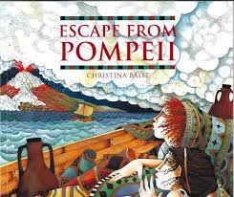
 |  |  |  |  | English |  | This term in English, the children will be reading Roman Diary: The journal of Iliona. They will be writing a ‘rags to riches’ tale as well as writing a non-chronological report.
 |  |  |  |  | Maths |  | As mathematicians, the children will be completing their learning on addition and subtraction, then starting multiplication and division. They will be using their reasoning and problem-solving skills to enhance their mathematical thinking.
 | What did the Romans do for us? |  |  |  | Science |  | In Science, we will be learning about forces and magnets. We will investigate the strength of magnets, compare how things move on different surfaces and categorise magnetic and non-magnetic materials.
 |  |  |  |  | History |  | In History, the children will be looking at the Romans. They will be investigating what the Roman’s have done to help us in current life. They will be exploring Roman Britain and significant battles including Boudicca and the Battle of Watling Street.
 |  |  |  |  | ART |  | This term, the children will be creating their own Roman mosaic. They will be looking at the importance of mosaics, learning about repeating patterns and designing and making their own mosaic. These will then be showcased to parents at the end of the term.
 |  |  |  |  | PSHE/RE |  | In PSHE this term, we are going to be looking at celebrating differences between people.  In RE, we are going to be looking at Christianity. In particular, the children are going to be focusing on the Christmas Story.
 |  |  |  |  | Music |  | In Music, the children will be learning the song ‘Bringing Us Together’. This is a disco song about friendship, peace, hope and unity. The children will also be learning to play the glockenspiel in tune with the song.

