 |  |   Year 1 Autumn 2  Topic Overview – There’s No Place Like Home  The children will be exploring key human features, e.g. cities, towns and shops within their local area. They will be learning to identify the countries that make up the United Kingdom and use simple compass directions. (North, South, East and West). We will be exploring the local environment and our surroundings.
Super Start: We will be looking at different types of homes. We will design a room and use cardboard boxes and recycled materials to bring it to life! We will be going on a scavenger hunt to find key features of the United Kingdom. Children can come into school dressed up as their dream job.
Epic End: Learning Showcase Assemblies
Our Learning Overview
Key Texts

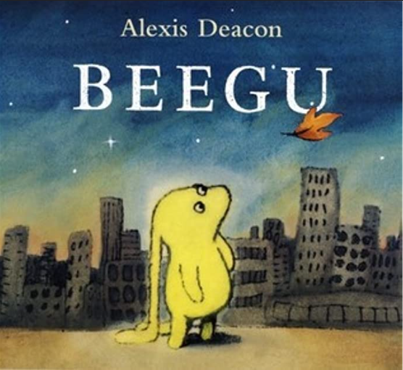

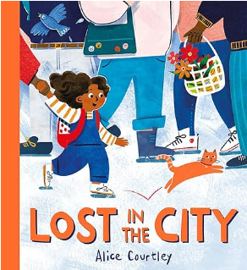
 |  |  |  |  | English |  | In English, we will be focusing on the story ‘Beegu’. We will be making story maps to retell the story. We will write report information texts understanding and discussing the key text. We will also looking at journalistic report writing and plan a newspaper report around our key text.
 |  |  |  |  | Maths |  | In Maths, we will be continuing to develop our knowledge of place value with numbers to 10. We will be learning to add numbers to 10 and subtract within 10. We will be learning to use the part-whole model to partition numbers. We will be learning about fact families and number bonds within 10.
 | There’s No Place Like Home |  |  |  | Science |  | For our science learning, we will be learning about seasonal changes and plants. We will be exploring the differences between the different seasons focusing on how some plants change. We will be looking at evergreen and deciduous trees and recognizing what these two words mean.
 |  |  |  |  | Geography |  | In Geography, we are learning about our local area. We will identify local landmarks and talk about why they are important using Google Maps to navigate the local area. We will also learn to name the countries and capital cities in the UK.
 |  |  |  |  | Art |  | In Art, we will be exploring the work of Alexis Deacon. We will use her illustrations to create our own landscape from our core text ‘Beegu’ using painting and mixed media.
 |  |  |  |  | PSHE/RE |  | Our PSHE topic will be Celebrating Differences. We will look at similarities and differences between us and our friends and talk about what to do if we feel unhappy or feel like we are being bullied. In RE we will be learning about Christianity, focusing on the Christmas story and how it feels to receive a special gift.
 |  |  |  |  | Music |  | In Music, we will continue to learn to find the beat in a piece of music. We will be learning about rhythm and pitch and will be asking how music can tell stories about the past.

