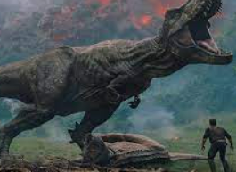 |  |   Year 2 Autumn 2  Topic Overview – Jurassic World  In this topic, the children will be learning all about the pre-historic period, focusing on dinosaurs! Children will be able to place events on a timeline in chronological order, classify characteristics for a range of dinosaurs, investigate if dinosaurs could live in the present day and explain the significance of Mary Anning.
Super Start: Children are to wear something dinosaur themed for our fossil hut. We will also be making dinosaur skeletons out of pasta and we will be matching pictures of dinosaurs to their names as we learn them.
Epic End: Learning Showcase Assemblies
Our Learning Overview
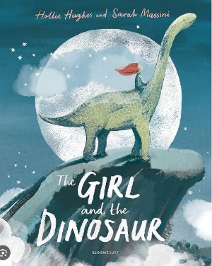
Key Texts

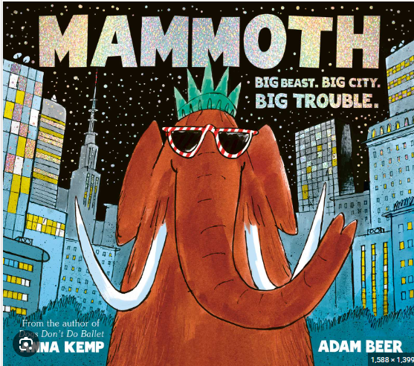
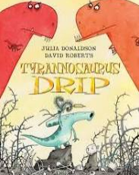
 |  |  |  |  | English |  | This term, children will be writing their own ‘defeating the monster’ story, focusing on defeating a dinosaur! They will be creating a character description, ensuring they are bringing their dinosaur to life. For their non-fiction, they will use their knowledge from their topic to write a non-chronological report about their chosen dinosaur.
 |  |  |  |  | Maths |  | In maths, we will be looking at addition and subtraction with 2-digit and 3-digit numbers. We will also be looking at shapes, exploring both 2D and 3D shapes and their features.
 | Jurassic World |  |  |  | Science |  | In science this term we will be learning about Living Things and their Habitats. Year 2 will be learning about different habitats and the microhabitats within them. Our aspiration for this term is a zoologist!
 |  |  |  |  | History |  | In history we will be taking an exciting trip back in time to the land of the dinosaurs! Children will be learning about the different three Triassic, Jurassic and Cretaceous periods, as well as identifying the dinosaurs which lived then.
 |  |  |  |  | DT |  | In DT we will be learning about making healthy choices, trying some different healthy foods and making a healthy sandwich. The children will learn to slice vegetables, butter the bread and put the sandwich together.
 |  |  |  |  | PSHE/RE |  | In PSHE this term we will be learning about “celebrating difference.” This will give us the opportunity to talk about how we are similar and different to our friends. In RE we will be looking at the birth and life of Jesus.
 |  |  |  |  | Music |  | In music, we will continue to learn to find the beat in a piece of music. We will be learning about rhythm and pitch and asking how music can tell stories about the past.

