Year 5 Autumn 2
Topic Overview – The Ancient Kingdom of Benin
This term children will be exploring the Benin Kingdom. We will deep dive into the wonders of this almost forgotten kingdom that inspired so much of what we do in current times.
 | Super Start: Year 5 will be creating artwork inspired by Africa and diving deeper into the culture of West Africa.  Fab Finish: Learning showcase. |  |  |  |  |  |  |  | Educational visit: The Horniman Museum
Our Learning Overview
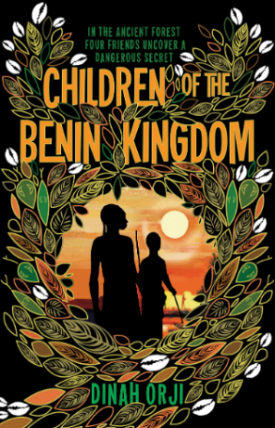
Key Texts

 |  |  |  | English |  | This term in English, the children will be writing a range of genres including narratives, report information texts and journalistic writing. Grammar features that will be explored include writing with a range of clauses, noun phrases, modal verbs, parenthesis, commas, colons and hyphens. Throughout English sessions spellings will be explicitly taught, with spelling tests continuing on Mondays.
 |  |  |  | Maths |  | In Maths we will be building on our fraction knowledge, relating it to finding equivalent fractions, converting improper fractions to mixed numbers and converting mixed numbers to improper fractions. After this, we will continue our multiplication and division topic where will be focusing on multiplying up to 4-digit by 2-digit numbers and solving problems with multiplication.
 | The Ancient Kingdom of Benin |  |  | Science |  | Science this term explores Earth and Space. Within this topic, children will be describing the movement of the Earth and other planets relative to the sun in the solar system, the movement of the moon relative to the Earth and the sun, Earth and moon as approximately spherical bodies. We will also be using the idea of the Earth’s rotation to explain day and night.
 | The Ancient Kingdom of Benin |  |  | History |  | In Topic (History) we will be looking at the Golden age of Benin, thinking about where it places in the timeline of ancient kingdoms and where we would find Benin on a map. We will be studying the social hierarchy of Benin at this time, as well as discussing the kingdom’s art and culture. We will also be discussing the kingdom’s decline, looking at the role that Britain played in this.
 | The Ancient Kingdom of Benin |  |  | DT |  | In DT, Year 5 will be making their own bread! Children will explore bread making from research to evaluation. They will also learn and practice fundamental bread-making skills such as kneading, proving, and baking.
 |  |  |  | PSHE/RE |  | Our learning in RE this term will focus on the Easter story and the life of Jesus, discussing the purpose of Jesus’ crucifixion and how this is remembered by Christians. In PSHE will focus on ‘Celebrating Differences’. We will look at similarities and differences between people in our community.
 |  |  |  | Music |  | Music will be taught weekly, focusing on using skills of tone and pitch as well as using a range of instruments.

