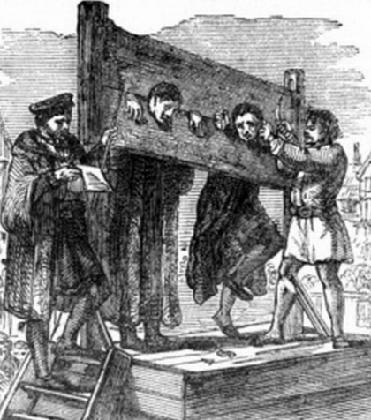 |  |  |  |   Year 6 Autumn 2  Topic overview-  This term we will be continuing out topic of ‘Crime and Punishment’. We will continue to look at crimes and punishments through the eras and how they have changed. We will explore why the justice system is used in everyday settings and what is in place to ensure we have a society that people are happy to be a part of.
 |  |  |  | Super Start: Children will become detectives and play a game of guess who in our ‘Who done it?’ afternoon.  Fab Finish: Parent showcases. |  |  |  | Educational Visit  Junior Citizen Workshop
Our Learning Overview
Key Texts

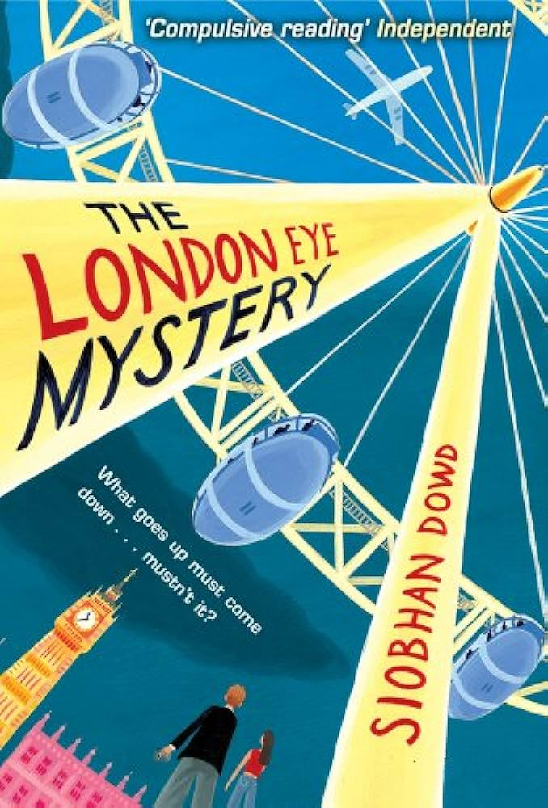
 |  |  |  |  | English |  | Children will begin the term focusing on the genre of narrative. They will work on including character dialogue into their writing to convey characters and advance the action in the story. Following this, children will then work to develop their report writing and develop on their use of commas, dashes, colons and brackets to indicate parenthesis. As well as this, children will develop their journalistic writing and use direct speech and formal language.
 |  |  |  |  | Maths |  | In Maths, we will be developing our understanding of the four operations focusing on long division and order of operations. We will also be developing our fractions knowledge to solve multi-step problems and begin looking at units of measure.
 | Does the time fit the crime? |  |  |  | Science |  | In Science, we will be looking at light. By the end of this unit, we will be able to explain that we see things because of light travelling between light sources and our eyes and understand that light travels in straight lines. Our key scientist will be Thomas Edison his invention of the modern light bulb.
 | Does the time fit the crime? |  |  |  | History |  | In History, we will be continuing with our topic: Does the Crime Fit the Time? Children will conduct a case study of Carl Hans Lody. They will learn about crime and punishment during WWII. In addition to this, pupils will investigate the concept of rehabilitation and punishment within the prison system.
 | Does the time fit the crime? |  |  |  | DT |  | In DT, we will be designing and creating our own gadget. The idea of our gadget will be linked to our English lesson and this will be the item that helps to solve the problem from our stories.
 |  |  |  |  | PSHE/RE |  | In RE, we will be exploring how Christians celebrate Christmas. We will discuss the Christmas story and the different ways in which people celebrate. In PSHE, we will be looking at ourselves and the similarities and differences we share with our peers and the others around us.
 |  |  |  |  | Music |  | In music, we will be developing an understanding of musical composition, organising and manipulating ideas within musical structures and reproducing sounds from auditory memory.

