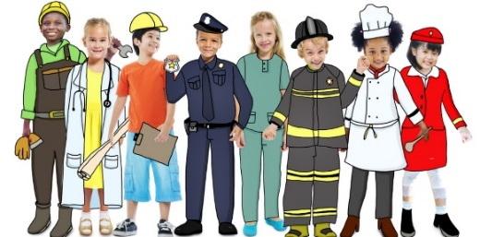 |     Nursery Spring 1  Topic Overview – Help is on the Way  This term in Nursery we will continue to learn through carefully chosen key texts. We will learn about people that help us, for example doctors, nurses, firefighters, police, lollypop people, teachers, adults in our family and so many more!
Super Start: On Tuesday 6th January 2026 children can dress up as someone who helps us. We will explore through role play and introduce our new text ‘A Superhero Like You.’ We will immerse ourselves in activities indoors and outdoors.
Marvellous Middle- Children will get to meet some of our real-life superheroes from the emergency services.
Epic End – Family Fun Session.
Our Learning Overview
Key Texts

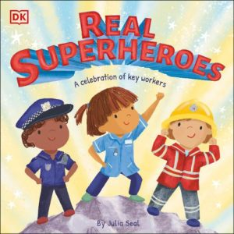
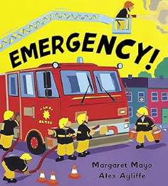




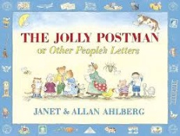
Topic Vocabulary
- Teaher  - Teaching Assistant  - Nursery Nurse  - Caretaker  - Cook  - Headteacher  - Cleaner | - Doctor  - Nurse  - Firefighter  - Policeman/Policewomane  - Paramdeic  - Lollipop Lady/Man  - Postman/Postwoman | - Care  - Teach  - Help  - Listen  - Community
Real Superheroes | Topsy and Tim Meet the Police | Emergency | Farmer Duck | The Jolly Postman | Hospital Dog
Superhero  Doctor  Help  Kind  Brave  Care  Caring  Patient  Friendly  Power  Heart  Kindness  Healthy  Confidence  Smiling  Role Model | Police  Officer  Badge  Car  Lights  Siren  Help  Safe  Rules  Emergency  Police Station  Uniform  Respect  Listen  Talk  Friend | Firefighter  Ambulance  Rescue  Truck  Paramedic  Fire  Save  Ladder  Danger  Team  Alert  Hurt | Farmer  Duck  Farm  Animals  Work  Sleep  Lazy  Quack  Barn  Chores  Tired  Funny  Cooperate  Busy  Moo  Cluck | Postman  Letter  Envelope  Stamp  Mailbox  Deliver  Post  Address  Happy  Recipient  Card  Route  Gift  Town  Village  Bear  Royal  Nice | Dog  Hospital  Nurse  Patient  Visit  Comfort  Sad  Care  Tail  Paw  Bark  Medicine  Bed  Smile  Love  Play  Well

