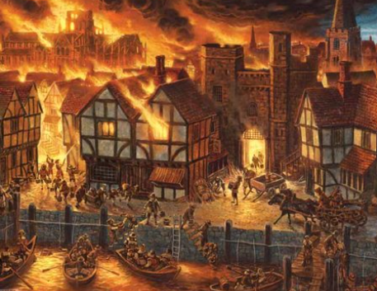 |  |  |  |   Year 2, Spring 1: London’s Burning  Topic Overview – This term children will be looking at the events that led up to the worst fire in British history. We will be focusing on Samuel Pepys, the bakery and how people felt and reacted to the disaster.
Super Start: Children can dress up as a baker or firefighter. We will also be making bread rolls and creating fire paintings.
Epic End: Bread bake off with year two from Fairford!
Our Learning Overview
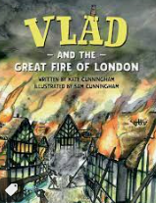
Key Texts
Vlad and the Great Fire of London.
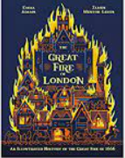
(Kate Cunningham)
The Great Fire of London
(Emma Adam)
 |  |  |  |  | English |  | In English we will be children will be writing a news report about a fictional fire that has broken out in school. The children will also be writing instructions on how to put out a fire.
 |  |  |  |  | Maths |  | In Maths, we will be learning all about money. We will be looking at the value of coins and notes, as well as exploring what we could buy with a given amount of money. We will also be starting to look at multiplication and division, focusing on the 2, 5- and 10-times tables.
 | London’s Burning |  |  |  | Science |  | This term in science, we will be looking at animals, including humans. We will be looking at the different basic needs of animals for survival and the importance of different foods, hygiene and exercise for humans.
 | London’s Burning |  |  |  | History |  | This term in History we will be learning about The Great Fire of London. We will be comparing the past to now and looking at the impact the event had on London. We will take a walk down memory lane and recapture the events of The Great Fire of London.
 | London’s Burning |  |  |  | Art |  | In Art this term we will be exploring the artwork of Frank Bowling. We will be using his artwork as inspiration to create our own abstract paintings based around the Great Fire of London.
 |  |  |  |  | PHSE/RE |  | In PSHE in Spring 1, we are looking at dreams and goals. We will focus on school dreams and goals and also those for our futures. In RE we will be focusing on Islam. We will learn about Islamic beliefs, the place of worship and the rituals they follow.
 |  |  |  |  | Music |  | This term in music, year 2 are looking forward to working with Ms Glasser again, exploring a variety of music styles and instruments.

