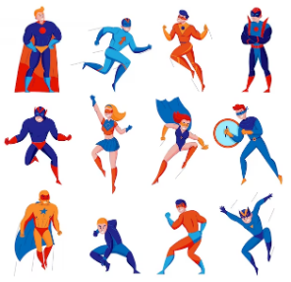 |  |   Year 3 Spring 1  Topic Overview – Do all Heroes wear capes?  This term, the children are looking at local heroes. We will be identifying where these heroes are in comparison to our school. The children will be able to identify 4 figure grid references by the end of this term and recognise how maps have changed over time.
 |  | Super Start: The children will dress as superheroes for the day. They will be looking at local heroes and identifying where they are on a map. We will also use our map skills for some orienteering on the school site. |  |  |  |  |  | Educational Visits:  Tump 53 Nature Reserve
Our Learning Overview
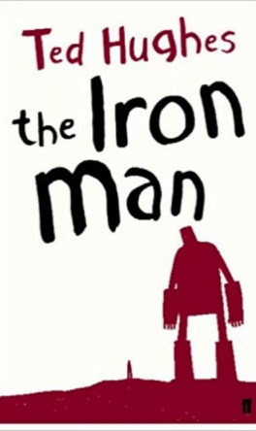
Key Texts

 |  |  |  |  | English |  | In English, the children will read The Iron Man and develop their writing skills through persuasive, narrative and explanation texts, focusing on clear paragraphs and sentence structure.
 |  |  |  |  | Maths |  | In Maths, we will be consolidating our understanding of multiplication and division. We will also be learning about length and perimeter, strengthening our understanding of units of measure including: metres, centimetres and millimetres.
 | Do all Heroes wear capes? |  |  |  | Science |  | As scientists, the children will learn about Animals Including Humans, where they will explore different types of food and the parts and functions of the human and animal skeleton.
 |  |  |  |  | Geography |  | In Geography this term, the children will be exploring maps. They will be looking at map symbols, using digital maps and using their map knowledge to partake in a walk around the local area.
 |  |  |  |  | Art |  | In Art we will be exploring the artwork of Andy Goldsworthy and Richard Shelling. We will use their artwork as inspiration to create our own sculpture using natural resources.
 |  |  |  |  | PSHE/RE |  | In PSHE, we will be exploring our dreams and goals and learning about the importance of having a growth mind set!. In R.E, we will be learning about the Miracles of Jesus and how this relates to our lives.
 |  |  |  |  | Music |  | In Music, we will be continuing our music lessons through listening, singing and performing.

