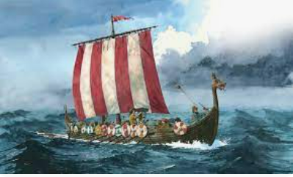 |  |   Year 4 Spring 1  Topic Overview – Raid, Invade and Stayed  This term, we will be learning all about the Anglo Saxons. We will learn about how they came to invade and settle in Britain after the fall of the Roman Empire. We will also examine their lasting impact, especially in our local area.
 |  | Super Start: Children will look at pictures of artefacts and ask questions, they will also make a design for a longboat dragon and explore the Viking alphabet and design their own shield! Children come dressed as an Anglo Saxon or Viking!
Our Learning Overview
Key Texts

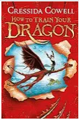

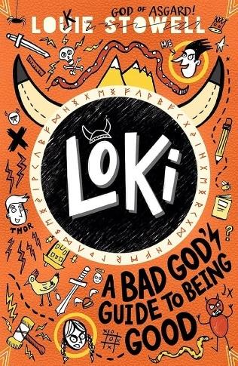

 |  |  |  |  | English |  | In English this term we will be exploring a range of genres including writing persuasively, a narrative, an explanation and poetry.  We will be basing our writing off of our key text that we’ll be looking at this term.
 |  |  |  |  | Maths |  | In Maths, we will be finishing multiplication and division using written methods and learn how to calculate length and perimeter. We will also be starting fractions.
 | Raid, Invade and Stayed! |  |  |  | Science |  | In Science we will be exploring the topic Electricity and how we use this within our environment. We will be able to identify and describe appliances that run on electricity and explain the process.
 |  |  |  |  | History |  | In History, we will be learning about the Anglo Saxons and Vikings. We will be exploring where they came from, how they invaded Britain and their lasting impact.
 |  |  |  |  | DT |  | In DT, children we will be learning textiles. We will learn basic sewing stitches using a needle and thread. We will then design our own Viking Illuminated letter which will be sewn onto fabric to create a Y4 collaborative piece.
 |  |  |  |  | PSHE/RE |  | In PSHE we will be exploring our dreams and goals. We will be learning how to deal with failure and what to do if we are unable to achieve one of our goals.  In R.E, we are answering the question ‘Can the Buddha’s teachings make the world a better place?’
 |  |  |  |  | Music |  | In Music, we will be learning the song ‘Stop!’ which is a grime song. We will also be writing lyrics linked to a theme.

