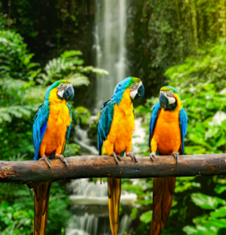 |  |   Year 5 Spring 1  Topic Overview – Do Rainforests Matter?  This term children will be exploring the rainforests. We will be learning about the biomes of the earth and the layers of the rain forest as well as the inhabitants of the rainforest; whether they are plants, animals or humans. We will also be learning about the pressures of modern-day life on the rainforest through exploring deforestation.
 |  | Super Start: Recreating rainforest paintings and learning about the rainforests of the world. |  |  |  |  |  |  |  | Educational visit: Trip to London Zoo.
Our Learning Overview
Key Texts
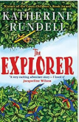

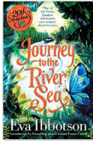

 |  |  |  |  | English |  | This term, we will be writing a range of genres including: narrative, persuasion, explanation and looking at poetry. The grammar features we will cover include: using the passive voice, cohesive devices, personification and rhyme.
 |  |  |  |  | Maths |  | In Maths, we will be consolidating our understanding of multiplication and division including multiplying by 2-digit numbers before moving onto fractions, as well as growing our problem solving and reasoning skills.
 | Do Rainforests Matter? |  |  |  | Science |  | In Science, we will be learning about Living Things and their habitats. We will be exploring how living things are classified into broad groups according to common observable characteristics and based on similarities and differences. We will also be focusing on classifying plants and animals based on specific characteristics.
 |  |  |  |  | Geography |  | In Geography, we will be exploring the rainforest and the impact this habitat has on the world as a whole. We will find out where in the world they are found, as well as exploring the impacts of deforestation on the world.
 |  |  |  |  | Art |  | In Art, we will build on our painting skills, developing our layering techniques. We will be exploring canonical artists, John Dyer and Henri Rousseau.
 |  |  |  |  | PSHE/RE |  | In PSHE we will be looking at our dreams and goals. We will be thinking about our aspirations and how to achieve our goals and dealing with our emotions. In RE we will be exploring the importance of Sikh stories in modern life.
 |  |  |  |  | Music |  | In Music, we will be continuing to learn how to play the ukelele.

