 | 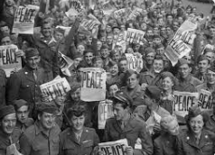 |  |   Year 6 Spring 1  Topic Overview – Keep Calm and Carry On  During this half –term, students will be exploring aspects of life during the Second World War. Children will be investigating the roles of significant leaders during this war and what warfare actually was like during that time.
Super Start: On Tuesday 6th January, we will be looking at propaganda posters and creating WW2 inspired art.
Marvellous middle:
Learning Showcases. Please see school calendar for the date.
 | Our Learning Overview
Key Texts

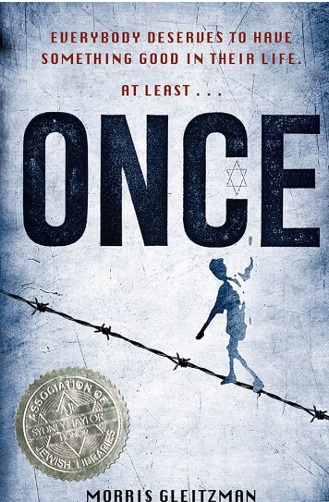

 |  |  |  |  |  | English |  | This term, we will be exploring persuasive writing, narrative writing and finishing our half term with a poetry week. In our grammar lessons we will explore the active and passive voice, subjunctive form and parenthesis.
 |  |  |  |  |  | Maths |  | This term in maths, we will be learning about ratio, algebra and decimals. We will be solving ratio problems relating to the real world. In algebra, we will be solving one and two-step equations. We will be learning how to round, add and subtract decimals before Spring 2.
 |  | Keep Calm and  Carry on |  |  |  | Science |  | In Science, we will learn about the appearance and function of different electrical components. We will discover how electrical cells produce a flow of electrons (current) and how we measure the power of a cell is voltage.
 |  |  |  |  |  | History |  | In History we will be learning about how WWII began, the key events during the war and the lasting impact the war had. We will also be focusing on key countries and people who contributed to the war.
 |  |  |  |  |  | Art/DT |  | In Art we will be exploring the artwork of Paul Cummins. We will use his work as inspiration to sculpt our own clay poppy.  In RE we will be exploring the questions ‘is anything ever eternal?’ as part of our Christianity topic.
 |  |  |  |  |  | PSHE/RE |  | In PSHE our topic is around dreams and goals. We will be focusing on what our hopes are as we begin to think about transitioning to secondary school.
 |  |  |  |  |  | Music |  | This unit of work will build on previous learning. We will continue with our violin learning.

